Site view and Client click on Get Data to fetch data from database
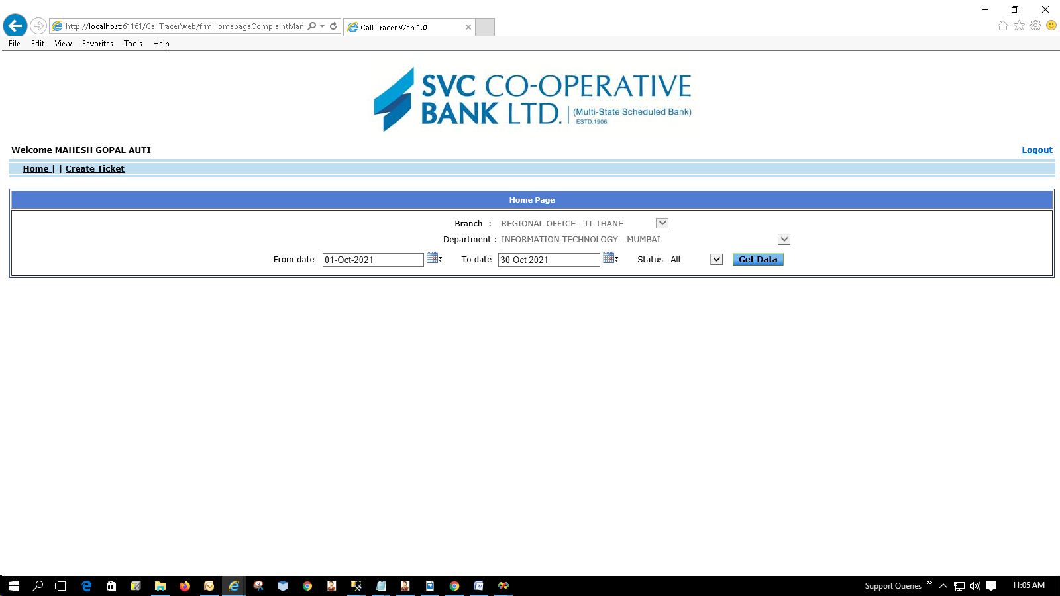

Design view and Solution Explorer of ASP.NET Project
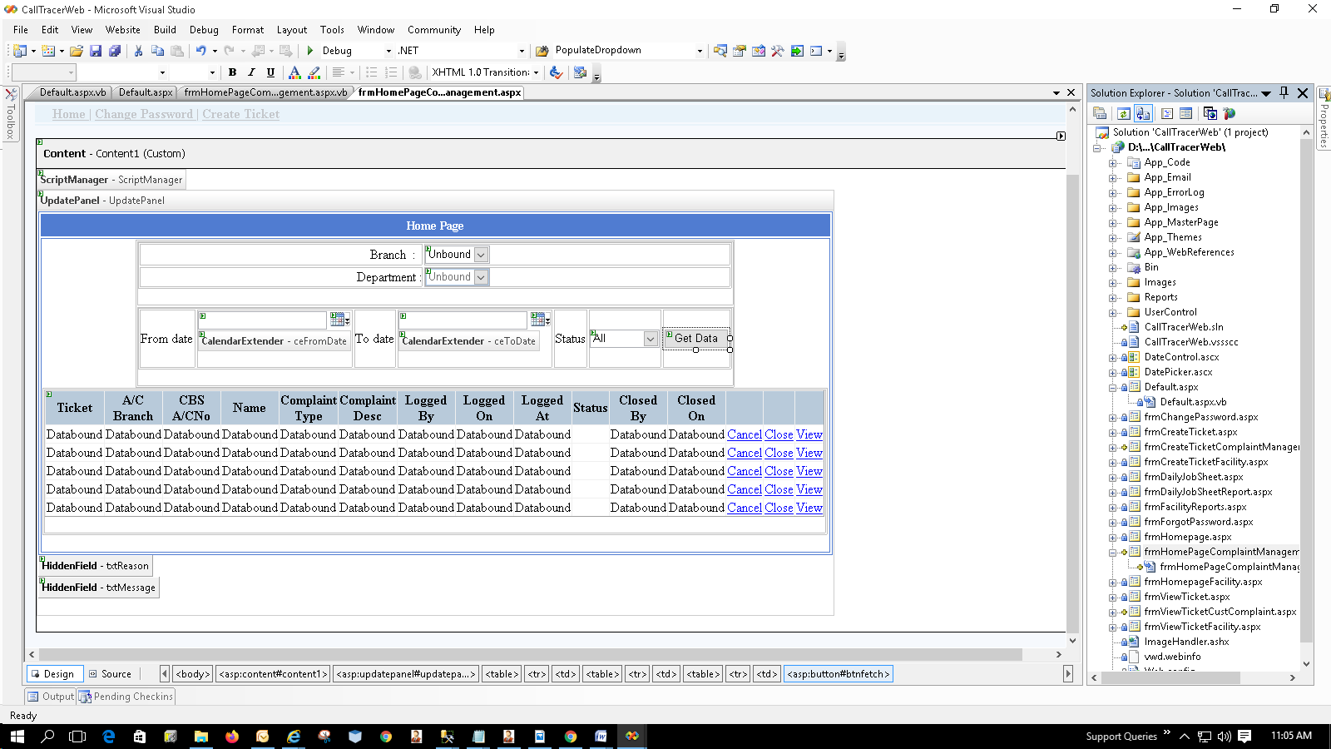

Add Web Reference
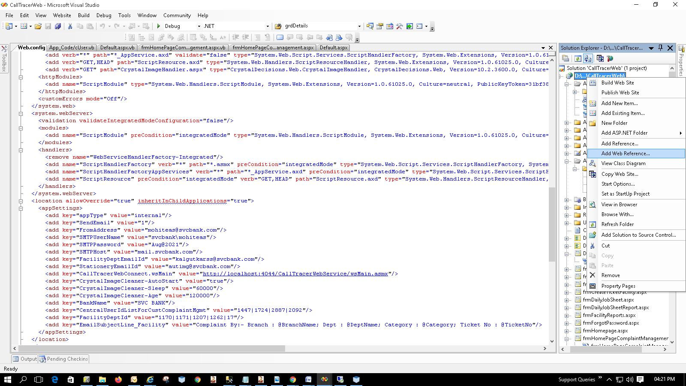

Add url and hit go and set web reference name
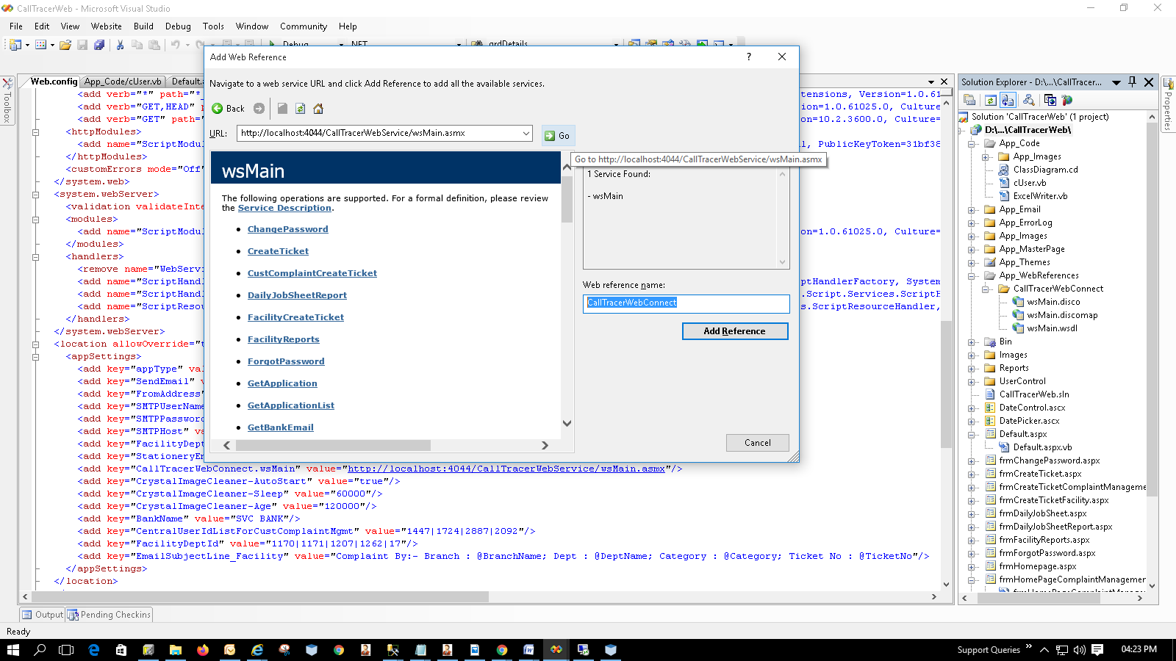

Web Service Project named CallTracerWebService is running
Web Reference added in ASP.NET Project (App_WebReferences – CallTracerWebConnect)
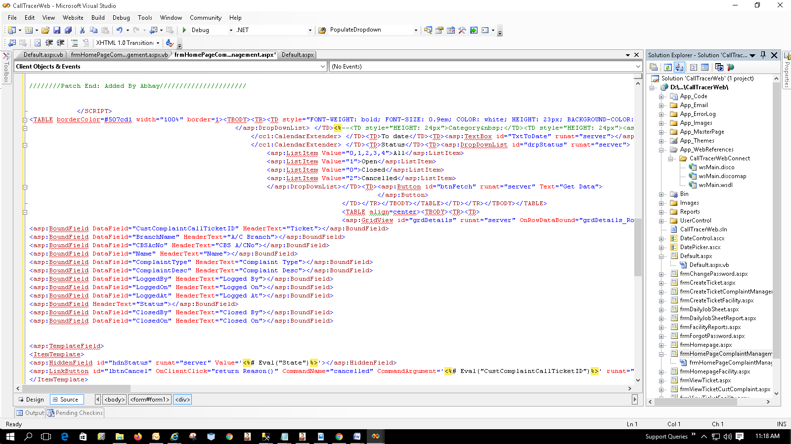

Code behind file
Web Service object created -- Dim mainhelper As New CallTracerWebConnect.wsMain
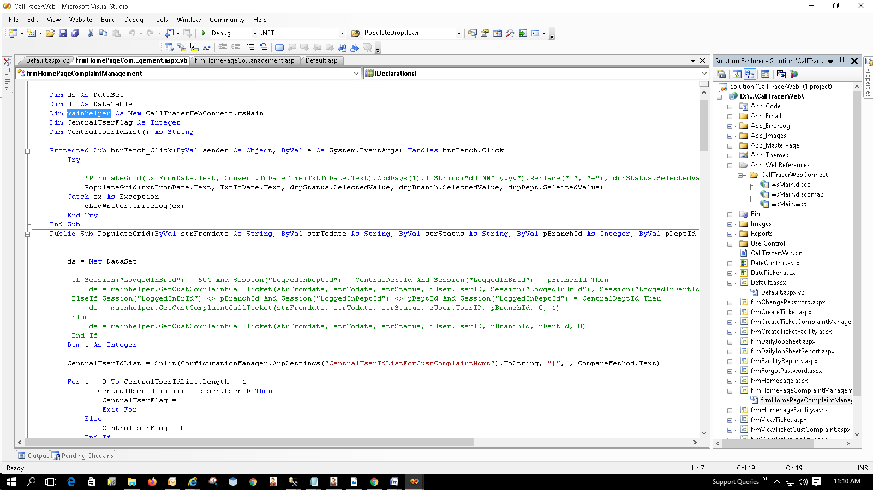

Get Data button event (btnFetch_Click) and calls web service function mainhelper.GetCustComplaintCallTicket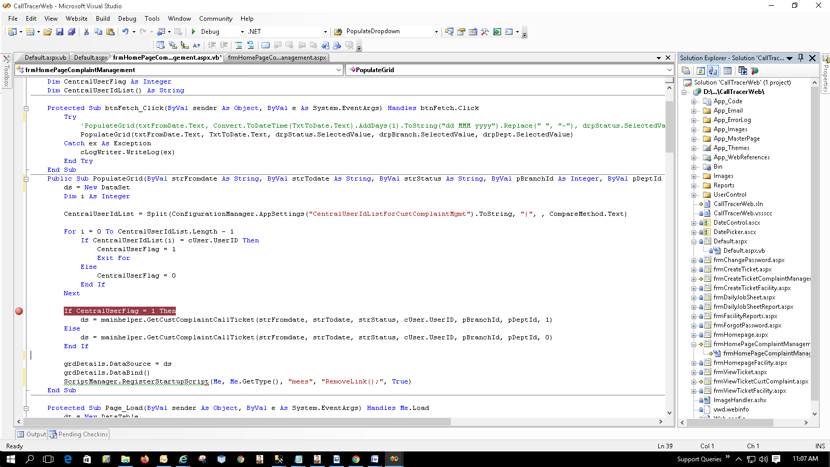

WebService Project and GetCustComplaintCallTicket function
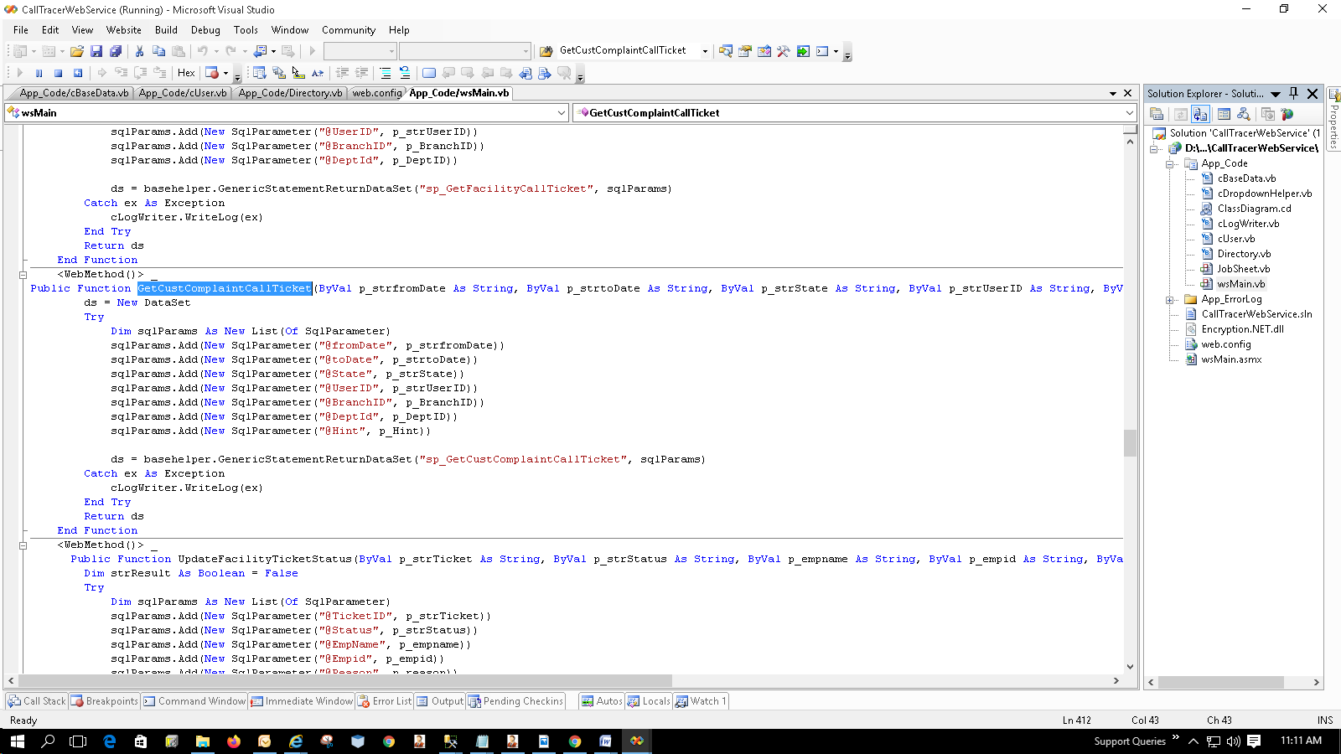

Query Execution and fill dataset
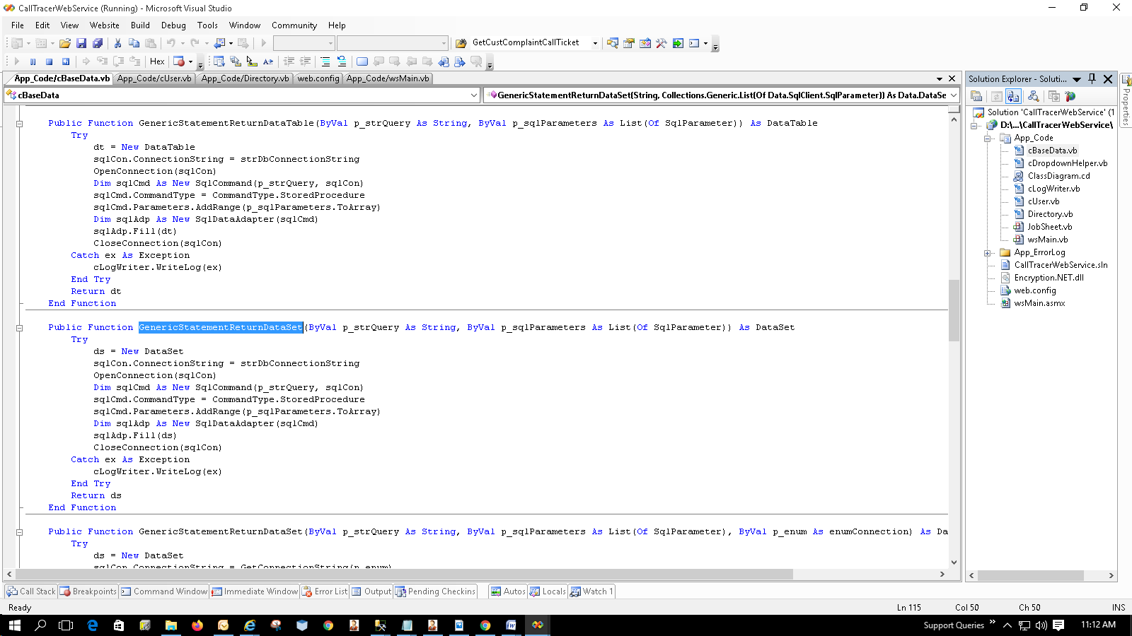

Fill grdDetails gridView using ds Dataset in asp.net project and DataBind
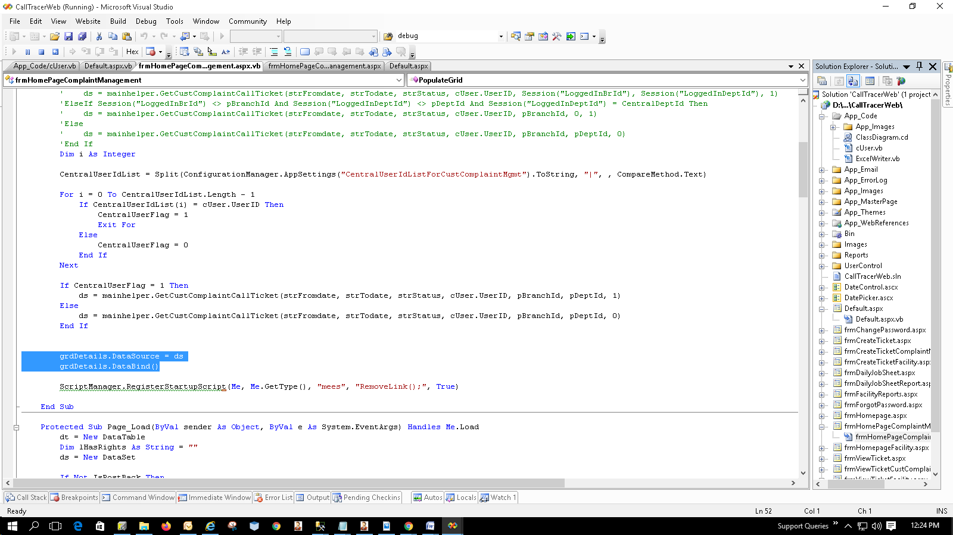

Fill GridView id="grdDetails"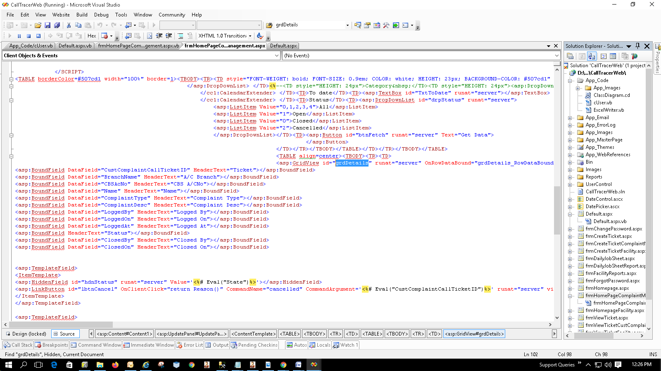

Populate data on client side
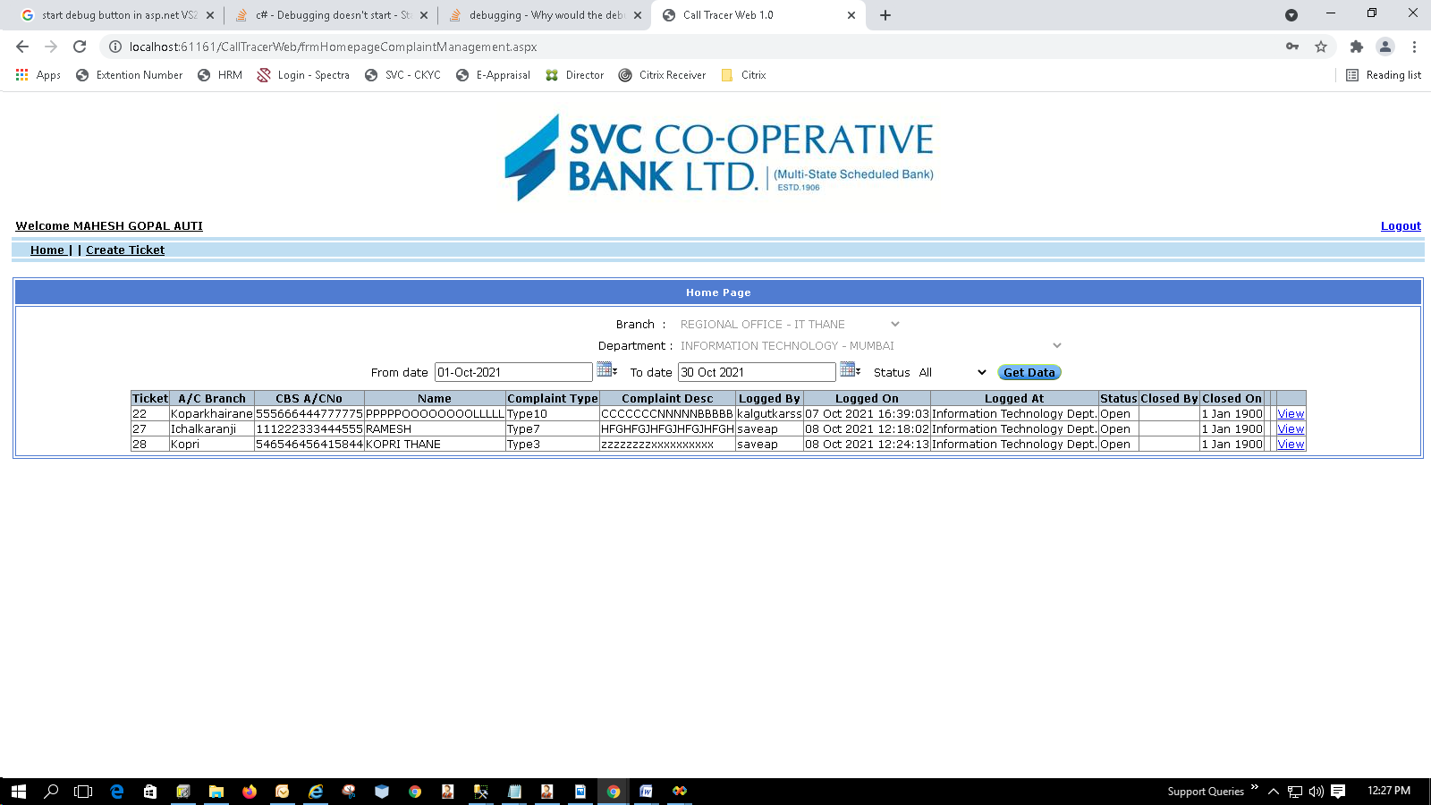
Web Service URL output
